EXPERIMENT NO. 1
Port Scanning Tools

AIM
To perform port scanning on a target host using Nmap and study different TCP/UDP scanning techniques available in Kali Linux.
TOOLS REQUIRED
- Kali Linux (with Nmap pre-installed)
- A target machine / IP address reachable on the network
- Terminal with root privileges
THEORY
Port scanning is the process of probing a target host to discover which TCP/UDP ports are open, closed, or filtered. Nmap supports several scan types, each using a different TCP flag combination or protocol behaviour to determine port state while varying in speed, stealth, and accuracy.
PROCEDURE
Step 1: Open Nmap from Kali Linux: Applications → Information Gathering → Nmap.
Step 2: Perform different types of scans — TCP, UDP, ACK, SYN, FIN, NULL, XMAS, RPC, Idle — using the scan types listed below.
SCANNING TECHNIQUES
Flag | Use | Example
-sS | TCP SYN port scan (stealth scan) | nmap -sS 192.168.1.1
-sT | TCP connect port scan | nmap -sT 192.168.1.1
–sU | UDP port scan | nmap –sU 192.168.1.1
–sA | TCP ACK port scan | nmap –sA 192.168.1.1

Note: SYN scan (-sS) is the default and most popular scan option since it is fast and stealthy. UDP scans (-sU) are typically slower due to the lack of a reliable handshake mechanism.

OUTPUT
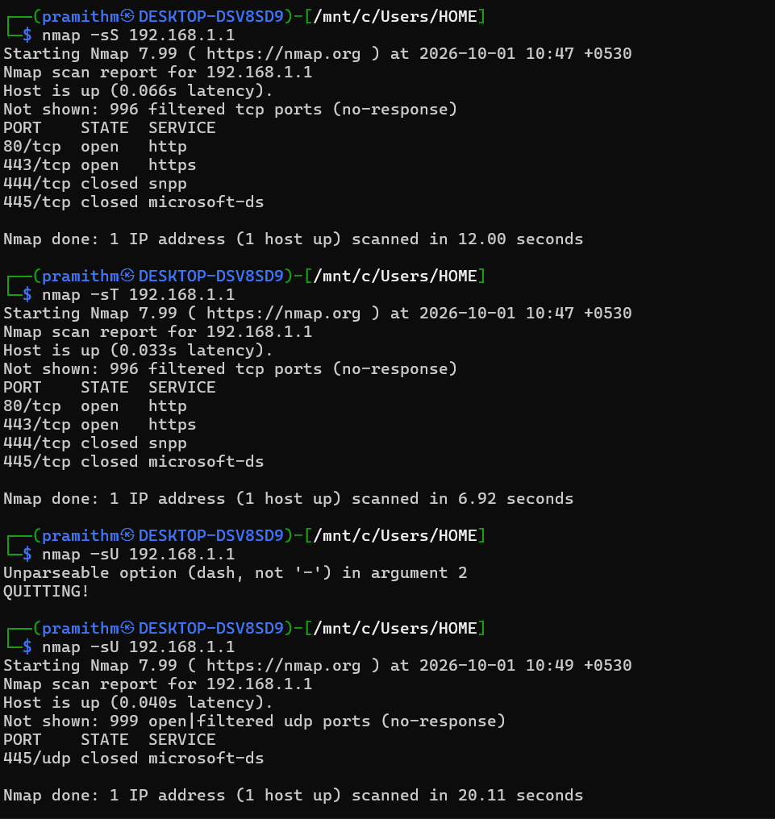

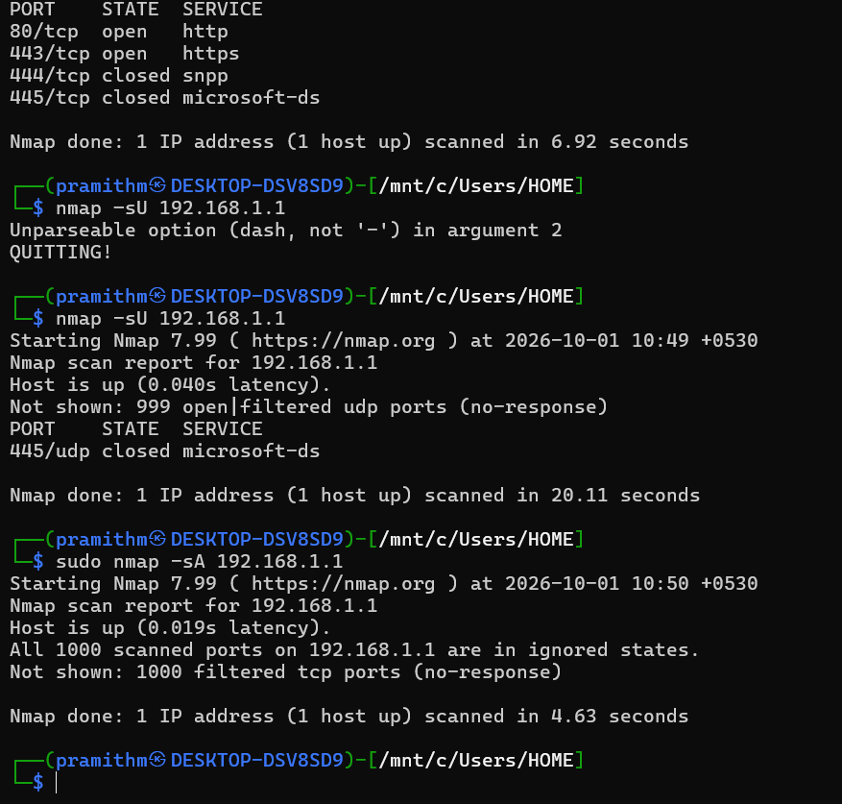
RESULT
Thus, port scanning on the target host 192.168.1.1 was successfully performed using Nmap with SYN, Connect, ACK, and UDP scan techniques, and the open/closed/filtered port states were observed and recorded.

